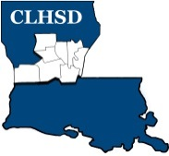
Central Louisiana Human Services District
Board Meeting Agenda
May 5, 2022

- Call to Order/Quorum
- Prayer/Pledge

- Read and Approve May 2022 Meeting Agenda
Solicit Public Comment Requests

- Approval of Minutes
- April 2022 Board Meeting Minutes

- District Reports

  - Financial Report H1
  - ED Monthly Report H2

- Policy Reviews
Executive Limits
  - II. F. Emergency ED Succession with corresponding procedure H3

- Board Business
- Board Development/Training– District Advisory Council
- Annual Ethics Training and completion of Tier 2.1 – Covering Calendar
Year 2021 to be completed by May 15th / signature page
- Board Member Self-Assessment distributed

- Next Month
- Convene nominating committee
- Review Board Member Self -Assessment
- Prioritized Strategic Initiatives for Coming Year

- Questions/Comments As Solicited

- Announcements
- Next meeting is June 2, 2022
- Adjourn

